Toroidal Surface

Definition
# Source: AI Source: Provided by: [Data Path: Persons Table -> ID Column: 1, Name_En Column: Motasem Essam] -> From: [ChatGPT] on [7/20/2026]
A Toroidal Surface is a curved surface generated by rotating a closed plane curve, commonly a circle, around an axis that lies in the same plane as the curve but does not intersect it.
The most familiar toroidal surface is produced by rotating a circle around an external coplanar axis. This produces a torus-shaped surface, resembling a doughnut or inner tube.
For a standard circular toroidal surface, the generating circle has:
- Minor radius $r$
- Major radius $R$
where $R>r$.
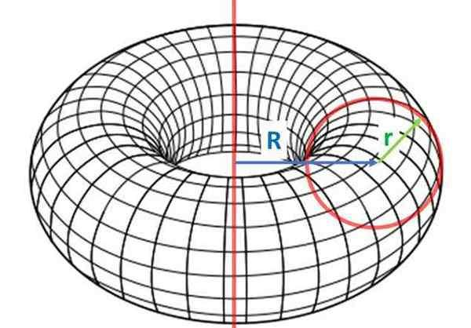
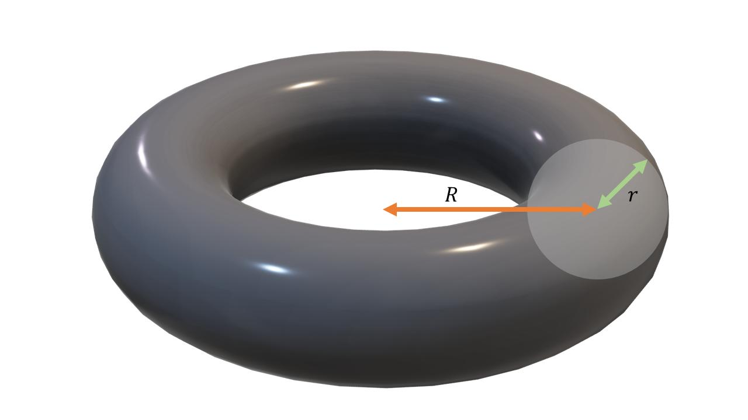
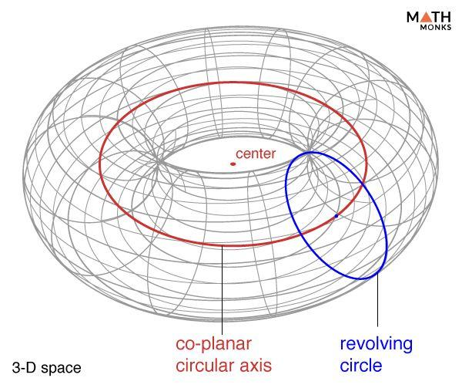
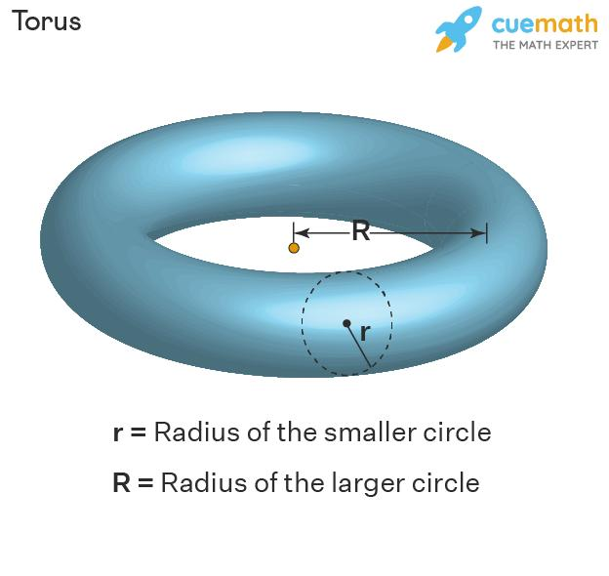
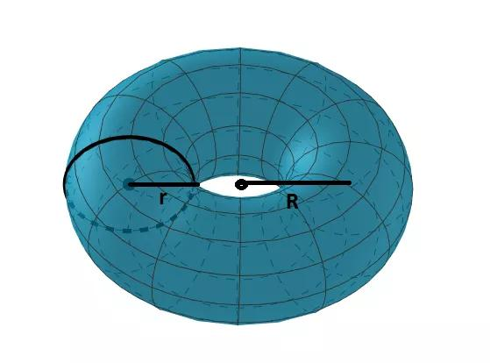
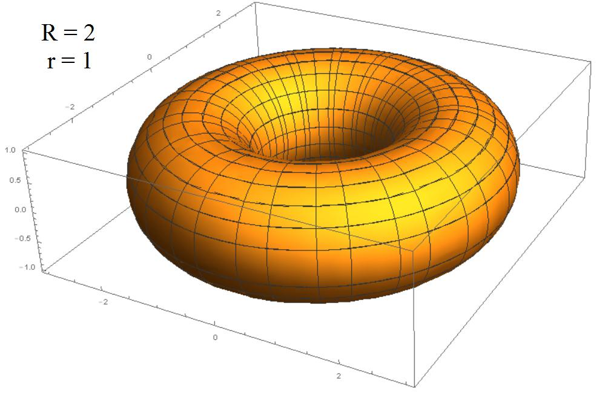

Purpose
# Source: AI Source: Provided by: [Data Path: Persons Table -> ID Column: 1, Name_En Column: Motasem Essam] -> From: [ChatGPT] on [7/20/2026]
A toroidal surface is used to:
- Describe the surface of a torus.
- Study curved surfaces generated by rotation.
- Calculate surface area and volume of a torus.
- Model rings, seals, tubes, and doughnut-shaped objects.
- Study surfaces in three-dimensional geometry.
- Connect geometry with parametric equations and rotational surfaces.

Fundamental Elements
# Source: AI Source: Provided by: [Data Path: Persons Table -> ID Column: 1, Name_En Column: Motasem Essam] -> From: [ChatGPT] on [7/20/2026]
For a standard circular toroidal surface, the main elements are:

1. Major Radius
# Source: AI Source: Provided by: [Data Path: Persons Table -> ID Column: 1, Name_En Column: Motasem Essam] -> From: [ChatGPT] on [7/20/2026]
The major radius $R$is the distance from the center of the torus to the center of the generating circular tube.
It measures the distance from the axis of revolution to the center of the generating circle.

2. Minor Radius
# Source: AI Source: Provided by: [Data Path: Persons Table -> ID Column: 1, Name_En Column: Motasem Essam] -> From: [ChatGPT] on [7/20/2026]
The minor radius $r$is the radius of the generating circle.
It determines the thickness of the torus.

3. Axis of Revolution
# Source: AI Source: Provided by: [Data Path: Persons Table -> ID Column: 1, Name_En Column: Motasem Essam] -> From: [ChatGPT] on [7/20/2026]
The axis of revolution is the line around which the generating circle is rotated.
For an ordinary torus, the axis does not intersect the generating circle.

4. Generating Circle
# Source: AI Source: Provided by: [Data Path: Persons Table -> ID Column: 1, Name_En Column: Motasem Essam] -> From: [ChatGPT] on [7/20/2026]
The generating circle is the circle that is rotated around the axis to create the toroidal surface.

5. Central Circle
# Source: AI Source: Provided by: [Data Path: Persons Table -> ID Column: 1, Name_En Column: Motasem Essam] -> From: [ChatGPT] on [7/20/2026]
The central circle is the circle formed by the centers of all the generating-circle positions during the rotation.
Its radius is the major radius $R$.

Mathematical Representation
# Source: AI Source: Provided by: [Data Path: Persons Table -> ID Column: 1, Name_En Column: Motasem Essam] -> From: [ChatGPT] on [7/20/2026]
A standard toroidal surface centered around the $z$-axis can be represented parametrically by:
$$x=\left(R+r\cos{v}\right)\cos{u} \\ y=\left(R+r\cos{v}\right)\sin{u} \\ z=r\sin{v}$$
where:
$$0≤u<2π$$
and:
$$0≤v<2π$$
Here:
- $R$= major radius
- $r$= minor radius
- $u$= angle around the main axis
- $v$= angle around the generating circle

Cartesian Equation
# Source: AI Source: Provided by: [Data Path: Persons Table -> ID Column: 1, Name_En Column: Motasem Essam] -> From: [ChatGPT] on [7/20/2026]
The standard toroidal surface can also be represented implicitly by:
$$\boxed{{\left(\sqrt{x^{2}+y^{2}}-R\right)}^{2}+z^{2}=r^{2}}$$
An equivalent polynomial form is:
$$\boxed{{\left(x^{2}+y^{2}+z^{2}+R^{2}-r^{2}\right)}^{2}=4R^{2}\left(x^{2}+y^{2}\right)}$$
These equations describe the surface of a standard circular torus.

Surface Area
# Source: AI Source: Provided by: [Data Path: Persons Table -> ID Column: 1, Name_En Column: Motasem Essam] -> From: [ChatGPT] on [7/20/2026]
For a standard toroidal surface, the surface area is:
$$\boxed{SA=4π^{2}Rr}$$
where:
- $R$= major radius
- $r$= minor radius
This result can be understood using Pappus's centroid theorem.
The generating circle has circumference:
$$2πr$$
Its center travels around the axis through a circle of circumference:
$$2πR$$
Therefore:
$$SA=\left(2πr\right)\left(2πR\right)$$
giving:
$$\boxed{SA=4π^{2}Rr}$$
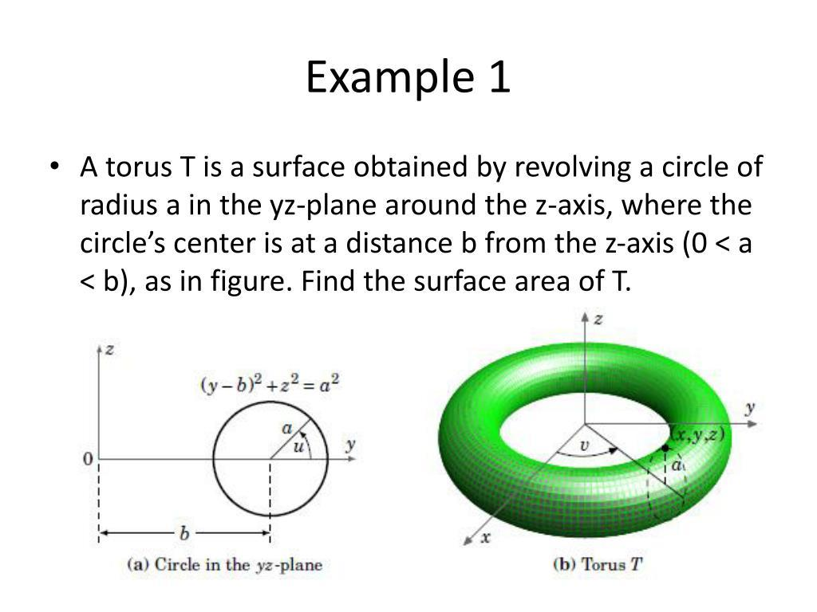

Volume Enclosed by a Torus
# Source: AI Source: Provided by: [Data Path: Persons Table -> ID Column: 1, Name_En Column: Motasem Essam] -> From: [ChatGPT] on [7/20/2026]
Although a toroidal surface itself has no volume, the closed toroidal surface encloses a solid region.
The volume of the corresponding solid torus is:
$$\boxed{V=2π^{2}Rr^{2}}$$
This is different from the surface area:
$$SA=4π^{2}Rr$$
So:
$$\boxed{\text{Toroidal Surface Area}=4π^{2}Rr}$$
while:
$$\boxed{\text{Enclosed Torus Volume}=2π^{2}Rr^{2}}$$

Main Properties
# Source: AI Source: Provided by: [Data Path: Persons Table -> ID Column: 1, Name_En Column: Motasem Essam] -> From: [ChatGPT] on [7/20/2026]
A standard toroidal surface has the following properties:
- It is a curved surface.
- It is generated by rotating a circle around an external coplanar axis.
- It has a major radius $R$.
- It has a minor radius $r$.
- It has no vertices.
- It has no sharp edges.
- It is a closed surface.
- It completely encloses a three-dimensional region.
- Its generating circle is closed.
- It has rotational symmetry around its axis.
- A standard circular torus has constant minor radius.
- Its surface area is:
$$\boxed{4π^{2}Rr}$$

Why a Toroidal Surface is Closed
# Source: AI Source: Provided by: [Data Path: Persons Table -> ID Column: 1, Name_En Column: Motasem Essam] -> From: [ChatGPT] on [7/20/2026]
Unlike the lateral surfaces of a cylinder or cone, a complete toroidal surface has no boundary curve.
The generating circle is closed, and rotating it through ${360}^{∘}$produces a continuous closed surface.
Therefore:
$$\boxed{\text{Toroidal Surface}=\text{Curved Surface}+\text{Closed Surface}}$$
This makes it similar to a spherical surface in its open/closed classification.

Types of Toroidal Surfaces

1. Ring Torus
# Source: AI Source: Provided by: [Data Path: Persons Table -> ID Column: 1, Name_En Column: Motasem Essam] -> From: [ChatGPT] on [7/20/2026]
A ring torus is the standard torus in which:
$$\boxed{R>r}$$
The generating circle does not intersect the axis.
This produces the familiar doughnut-shaped surface.

2. Horn Torus
# Source: AI Source: Provided by: [Data Path: Persons Table -> ID Column: 1, Name_En Column: Motasem Essam] -> From: [ChatGPT] on [7/20/2026]
A horn torus occurs when:
$$\boxed{R=r}$$
The generating circle touches the axis of revolution at one point.

3. Spindle Torus
# Source: AI Source: Provided by: [Data Path: Persons Table -> ID Column: 1, Name_En Column: Motasem Essam] -> From: [ChatGPT] on [7/20/2026]
A spindle torus occurs when:
$$\boxed{R<r}$$
The generating circle intersects the axis of revolution.
The resulting surface has a different shape from an ordinary ring torus.
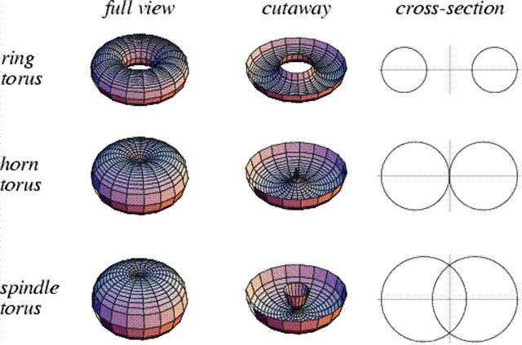
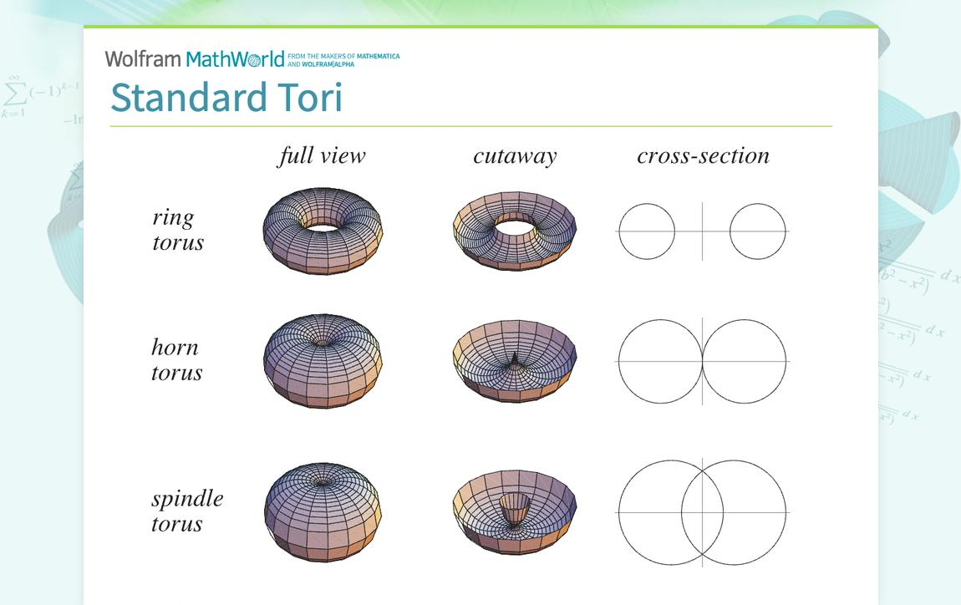
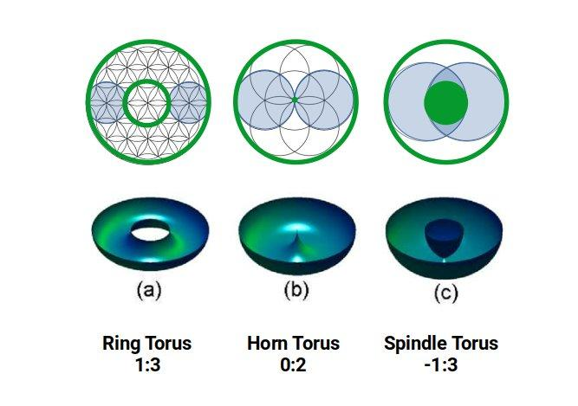

Types of Toroidal Surfaces
1. Ring Torus
A ring torus is the standard torus in which:
$$\boxed{R>r}$$
The generating circle does not intersect the axis.
This produces the familiar doughnut-shaped surface.
2. Horn Torus
A horn torus occurs when:
$$\boxed{R=r}$$
The generating circle touches the axis of revolution at one point.
3. Spindle Torus
A spindle torus occurs when:
$$\boxed{R<r}$$
The generating circle intersects the axis of revolution.
The resulting surface has a different shape from an ordinary ring torus.

Examples

Example 1: Finding the Surface Area
# Source: AI Source: Provided by: [Data Path: Persons Table -> ID Column: 1, Name_En Column: Motasem Essam] -> From: [ChatGPT] on [7/20/2026]
A toroidal surface has:
$$R=10\text{ cm}$$
and:
$$r=2\text{ cm}$$
Using:
$$SA=4π^{2}Rr \\ SA=4π^{2}\left(10\right)\left(2\right) \\ \boxed{SA=80π^{2}{\text{ cm}}^{2}}$$
Approximately:
$$\boxed{SA≈789.57{\text{ cm}}^{2}}$$

Example 2: Finding the Volume
# Source: AI Source: Provided by: [Data Path: Persons Table -> ID Column: 1, Name_En Column: Motasem Essam] -> From: [ChatGPT] on [7/20/2026]
Suppose:
$$R=10\text{ cm}, r=2\text{ cm}$$
Using:
$$V=2π^{2}Rr^{2} \\ V=2π^{2}\left(10\right)\left(2^{2}\right) \\ V=80π^{2}$$
Therefore:
$$\boxed{V=80π^{2}{\text{ cm}}^{3}}$$
Approximately:
$$\boxed{V≈789.57{\text{ cm}}^{3}}$$

Example 3: Identifying the Type of Torus
# Source: AI Source: Provided by: [Data Path: Persons Table -> ID Column: 1, Name_En Column: Motasem Essam] -> From: [ChatGPT] on [7/20/2026]
Suppose:
$$R=8\text{ cm}$$
and:
$$r=3\text{ cm}$$
Since:
$$R>r$$
the surface is a:
$$\boxed{\text{Ring Torus}}$$

Example 4: Horn Torus
# Source: AI Source: Provided by: [Data Path: Persons Table -> ID Column: 1, Name_En Column: Motasem Essam] -> From: [ChatGPT] on [7/20/2026]
Suppose:
$$R=5\text{ cm}$$
and:
$$r=5\text{ cm}$$
Since:
$$R=r$$
the surface is a:
$$\boxed{\text{Horn Torus}}$$

Toroidal Surface vs Torus Solid
# Source: AI Source: Provided by: [Data Path: Persons Table -> ID Column: 1, Name_En Column: Motasem Essam] -> From: [ChatGPT] on [7/20/2026]
It is important to distinguish the surface from the solid.
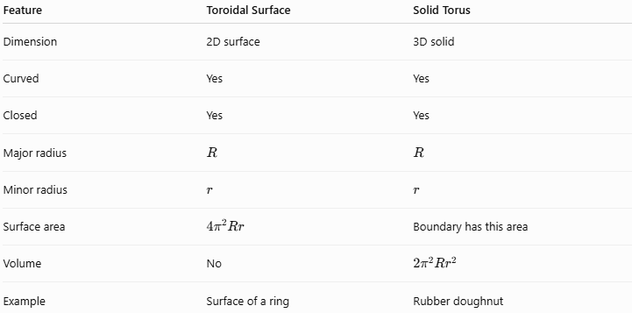
Feature | Toroidal Surface | Solid Torus
Dimension | 2D surface | 3D solid
Curved | Yes | Yes
Closed | Yes | Yes
Major radius | $$R$$ | $$R$$
Minor radius | $$r$$ | $$r$$
Surface area | $$4π^{2}Rr$$ | Boundary has this area
Volume | No | $$2π^{2}Rr^{2}$$
Example | Surface of a ring | Rubber doughnut
Thus:
$$\boxed{\text{Toroidal Surface}≠\text{Solid Torus}}$$
The toroidal surface is the boundary, while the solid torus includes the region enclosed by that surface.

Relationship with Other Curved Surfaces
# Source: AI Source: Provided by: [Data Path: Persons Table -> ID Column: 1, Name_En Column: Motasem Essam] -> From: [ChatGPT] on [7/20/2026]
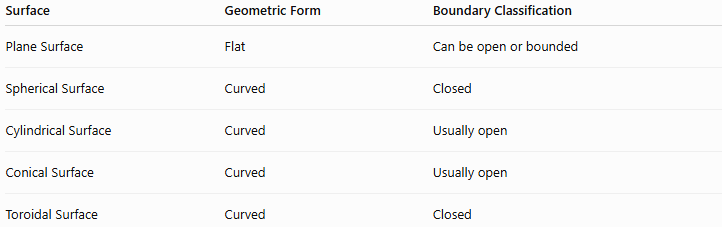
Surface | Geometric Form | Boundary Classification
Plane Surface | Flat | Can be open or bounded
Spherical Surface | Curved | Closed
Cylindrical Surface | Curved | Usually open
Conical Surface | Curved | Usually open
Toroidal Surface | Curved | Closed
Therefore:
$$\boxed{\text{Surface}→\text{Curved Surface}→\text{Toroidal Surface}}$$
and also:
$$\boxed{\text{Toroidal Surface}→\text{Closed Surface}}$$
These classifications are not mutually exclusive. A surface can simultaneously be classified by its geometric form and by whether it is open or closed.

Comparison with Spherical Surface
# Source: AI Source: Provided by: [Data Path: Persons Table -> ID Column: 1, Name_En Column: Motasem Essam] -> From: [ChatGPT] on [7/20/2026]
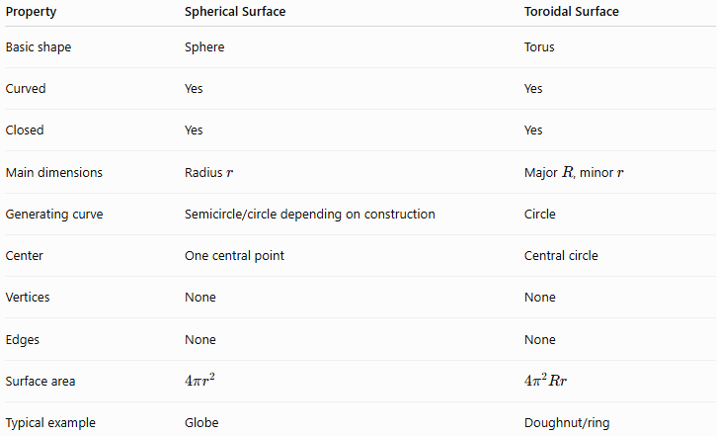
Property | Spherical Surface | Toroidal Surface
Basic shape | Sphere | Torus
Curved | Yes | Yes
Closed | Yes | Yes
Main dimensions | Radius $r$ | Major $R$, minor $r$
Generating curve | Semicircle/circle depending on construction | Circle
Center | One central point | Central circle
Vertices | None | None
Edges | None | None
Surface area | $$4πr^{2}$$ | $$4π^{2}Rr$$
Typical example | Globe | Doughnut/ring

Comparison with Cylindrical and Conical Surfaces
# Source: AI Source: Provided by: [Data Path: Persons Table -> ID Column: 1, Name_En Column: Motasem Essam] -> From: [ChatGPT] on [7/20/2026]
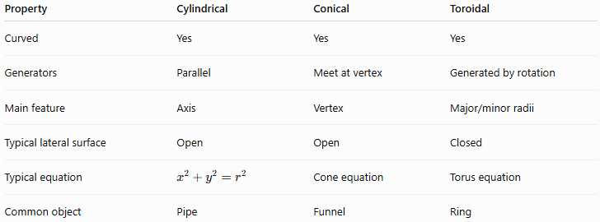
Property | Cylindrical | Conical | Toroidal
Curved | Yes | Yes | Yes
Generators | Parallel | Meet at vertex | Generated by rotation
Main feature | Axis | Vertex | Major/minor radii
Typical lateral surface | Open | Open | Closed
Typical equation | $$x^{2}+y^{2}=r^{2}$$ | Cone equation | Torus equation
Common object | Pipe | Funnel | Ring

Real-World Applications
# Source: AI Source: Provided by: [Data Path: Persons Table -> ID Column: 1, Name_En Column: Motasem Essam] -> From: [ChatGPT] on [7/20/2026]
Toroidal surfaces appear in:
- Doughnuts
- Inner tubes
- O-rings
- Rubber seals
- Gaskets
- Toroidal transformer cores
- Toroidal coils
- Mechanical bearings
- Ring-shaped tanks
- Some ventilation and fluid-flow components
- Certain optical and engineering components
For example, an O-ring has approximately a toroidal shape, while toroidal transformer cores use a similar geometry in electrical engineering.

Advantages
# Source: AI Source: Provided by: [Data Path: Persons Table -> ID Column: 1, Name_En Column: Motasem Essam] -> From: [ChatGPT] on [7/20/2026]
- Provides a precise mathematical model for ring-shaped objects.
- Has a simple surface-area formula for a standard circular torus.
- Has strong rotational symmetry.
- Useful in engineering and physics.
- Can be described using both parametric and Cartesian equations.
- Provides a useful example of a closed curved surface.

Limitations
# Source: AI Source: Provided by: [Data Path: Persons Table -> ID Column: 1, Name_En Column: Motasem Essam] -> From: [ChatGPT] on [7/20/2026]
- The formulas $4π^{2}Rr$and $2π^{2}Rr^{2}$apply to a standard circular torus.
- More general toroidal surfaces may have non-circular generating curves.
- The geometry is more complex than that of a sphere, cylinder, or cone.
- Real toroidal objects may not have a perfectly circular cross-section.

Key Points
# Source: AI Source: Provided by: [Data Path: Persons Table -> ID Column: 1, Name_En Column: Motasem Essam] -> From: [ChatGPT] on [7/20/2026]
- A Toroidal Surface is a curved surface generated by rotating a closed plane curve around an external coplanar axis.
- The standard toroidal surface is generated by rotating a circle.
- It has two important radii:
  - Major radius $R$
  - Minor radius $r$
- Its standard surface area is:
$$\boxed{SA=4π^{2}Rr}$$
- The corresponding solid torus has volume:
$$\boxed{V=2π^{2}Rr^{2}}$$
- A standard toroidal surface is a closed curved surface.
- The three main circular-torus forms are:
  - Ring torus: $R>r$
  - Horn torus: $R=r$
  - Spindle torus: $R<r$
- A toroidal surface has no vertices or edges.
- It is fundamentally different from a cylindrical or conical surface because its generating circle is rotated around an external axis and forms a closed ring.

Conclusion
# Source: AI Source: Provided by: [Data Path: Persons Table -> ID Column: 1, Name_En Column: Motasem Essam] -> From: [ChatGPT] on [7/20/2026]
A Toroidal Surface is an important type of curved surface formed by rotating a closed plane curve—most commonly a circle—around an axis in the same plane that does not intersect the curve. The resulting surface has a characteristic ring-like geometry described by its major radius $R$and minor radius $r$.
For a standard circular torus, its surface area is:
$$\boxed{SA=4π^{2}Rr}$$
and the enclosed solid has volume:
$$\boxed{V=2π^{2}Rr^{2}}$$
In the classification of surfaces, a toroidal surface is therefore:
$$\boxed{\text{Curved Surface}+\text{Closed Surface}}$$
making it a natural companion to the Spherical Surface within the closed curved-surface category.

